Word eBlast Template - Upload Test
[Instructions: Keep bracketed instruction labels in this document. Replace the sample words, links, and images with your real campaign content. The bracketed instructions will not appear in the generated HTML.]
Campaign Name: Sample eBlast Upload Test
Subject Line: See how your Word eBlast becomes email-ready HTML
Preview Text: This is sample preview/open text. Replace it with the short inbox preview for your campaign.
[Optional Style Notes: Keep this simple. Example: Headings blue, buttons orange, or use school colors. If you need an exact custom design, use the block designer or ask for design help.]
Style Notes: Use default colors
[Open Text: Replace the sample opening message below with the first sentence or two you want readers to see.]
[Image 1: Replace the sample image below with your final full-quality campaign image. In Word, click the image, then choose Picture Format > Change Picture. You may also delete it and use Insert > Pictures.]
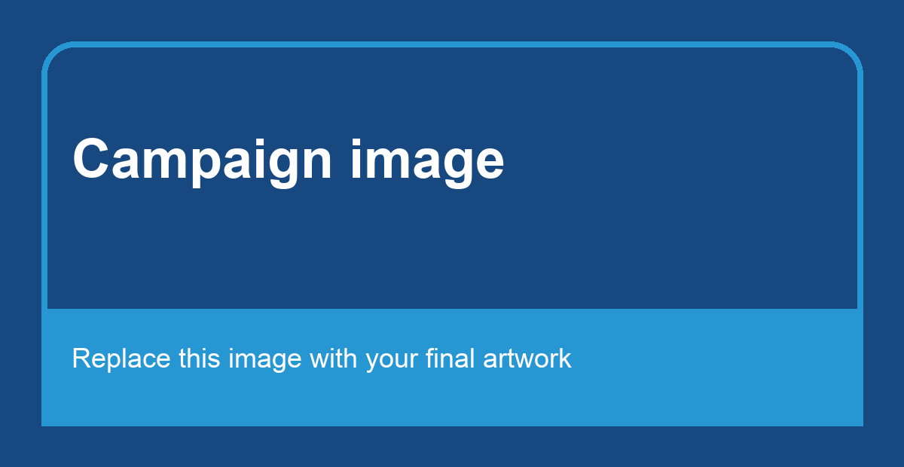
[Section Heading 1: Replace the heading below.]
Student travel creates moments that last.
[Section Copy 1: Replace this copy. Keep paragraphs short and direct.]
Use this space for the first section of campaign copy. Keep it clear, friendly, and easy to read in an email.
[Button Copy 1: Replace the button text below. Apply the final destination hyperlink to the button text.]
See The Story
[Image 2: Replace this sample image with the second campaign image, or delete this whole section if you only need one image.]

[Section Heading 2: Replace the heading below.]
Let us help you plan the next one.
[Section Copy 2: Replace this copy. Add another image, heading, copy, button text, and button link group if the email needs a third section.]
Use this section for the second image and message. Replace the sample image above with the final campaign image.
[Button Copy 2: Replace the button text below and apply the final hyperlink.]
Start Planning
[Before upload: confirm Campaign Name, Subject Line, Preview Text, images, button text, and links are final. Uploading creates draft HTML only; it does not send.]

